**eMart Project Design**

1. Project description

eMart is an online eCommerce portal used to search and buy an item online. Buyer can add items to the cart, checkout and perform other operations.Seller can add items and view inventory and generate report,too.

1. System Functions
   1. System Use Case Diagram

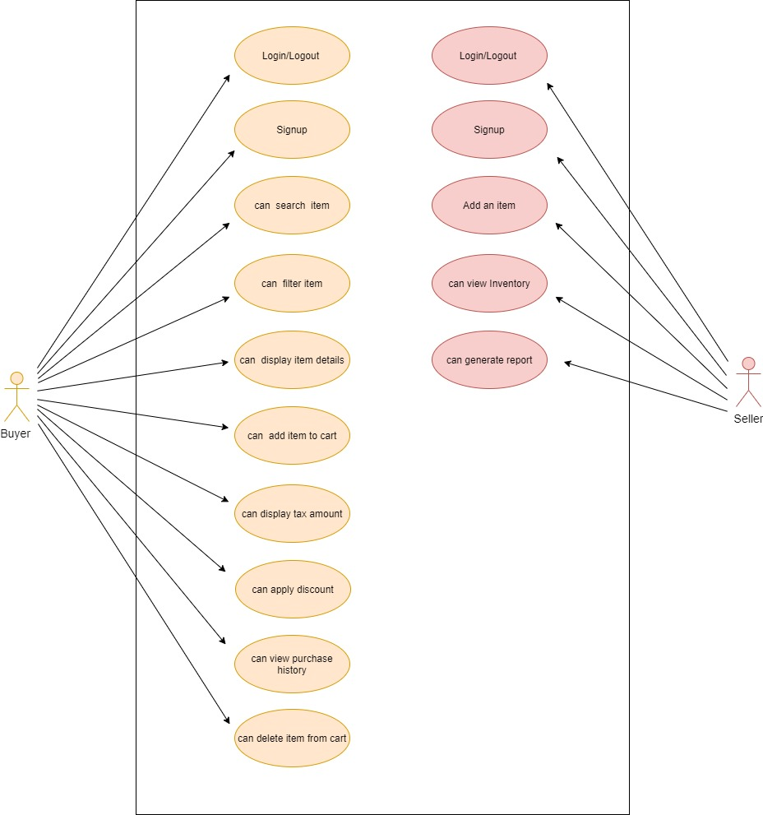

* 1. Use Case Description

2.2.1.

|  |  |
| --- | --- |
| Role | Buyer,Seller |
| Use Case | Login/Logout |
| Description | User can login and logout this system as a buyer or seller. |

2.2.2.

|  |  |
| --- | --- |
| Role | Buyer,Seller |
| Use Case | Signup |
| Description | One people can signup to a user of this system as a buyer or seller. |

2.2.3.

|  |  |
| --- | --- |
| Role | Buyer |
| Use Case | Can search item |
| Description | Use can search the item according to input conditions.  Such as: item name,price and so on. |

2.2.4.

|  |  |
| --- | --- |
| Role | Buyer |
| Use Case | Can filter item |
| Description | Once list of items are displayed, it should be possible to filter items based on Price, Manufacturer, etc... |

2.2.5.

|  |  |
| --- | --- |
| Role | Buyer |
| Use Case | Can display item details |
| Description | When a specific item is selected by Buyer, complete details of item need to be displayed along with picture(one or more) and (list of)specifications which depends on Category and Sub Category of the item. |

2.2.6.

|  |  |
| --- | --- |
| Role | Buyer |
| Use Case | Can add item to cart |
| Description | User can select items and add them into the cart. |

2.2.7.

|  |  |
| --- | --- |
| Role | Buyer |
| Use Case | Can display tax amount |
| Description | The tax amount of the item can be displayed in the cart. |

2.2.8.

|  |  |
| --- | --- |
| Role | Buyer |
| Use Case | Can apply discount |
| Description | Can apply discount, before checking out. |

2.2.9.

|  |  |
| --- | --- |
| Role | Buyer |
| Use Case | Can view purchase history |
| Description | Can view History of purchases, along with Item, numbers. |

2.2.10.

|  |  |
| --- | --- |
| Role | Buyer |
| Use Case | Can delete item from cart |
| Description | Can delete items from cart. |

2.2.11.

|  |  |
| --- | --- |
| Role | Seller |
| Use Case | Add an item |
| Description | User can add item to be sold along with the number of items. |

2.2.12.

|  |  |
| --- | --- |
| Role | Seller |
| Use Case | Can view Inventory |
| Description | User can view Inventory(items sold and remaining) |

2.2.13.

|  |  |
| --- | --- |
| Role | Seller |
| Use Case | Can generate report |
| Description | User can generate report like number of items sold and which items, over certain period. |

* 1. Function Modules

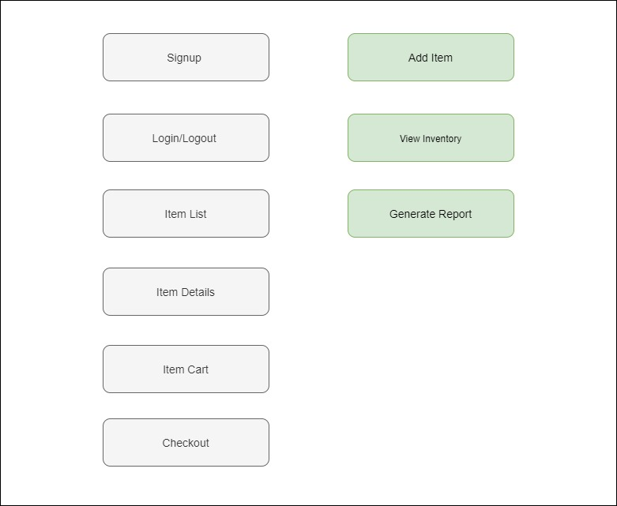

1. System Pages Description
   1. Pages List

|  |  |
| --- | --- |
| Page ID | Page Name |
| EMART001 | Signup Page |
| EMART002 | Login Page |
| EMART003 | Item List Page(Buyer) |
| EMART004 | Item Detail Page |
| EMART005 | Item Cart Page |
| EMART006 | Item List Page(Seller) |
| EMART007 | Item Add Page |
| EMART008 | Item Update Page |
| EMART009 | Item Report Page |

* 1. Pages Wireframe

EMART002:

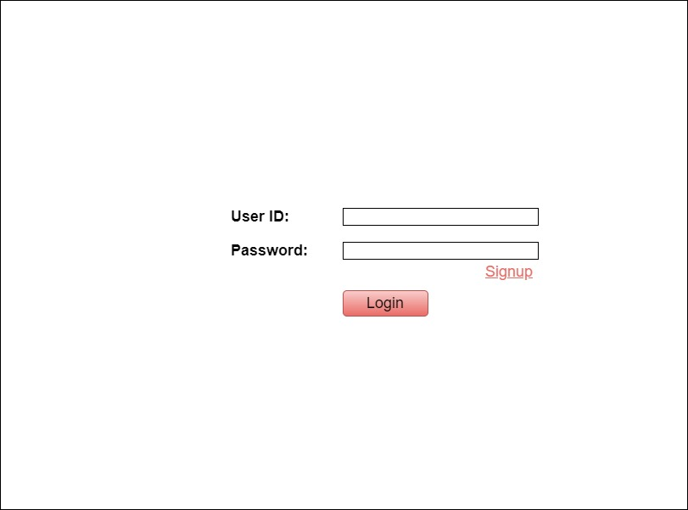

EMART001:

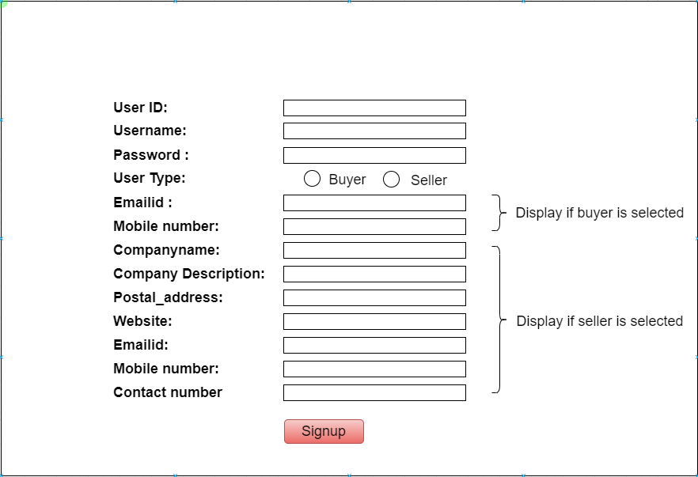

EMART003: [Buy Item] and [View Discounts] tab

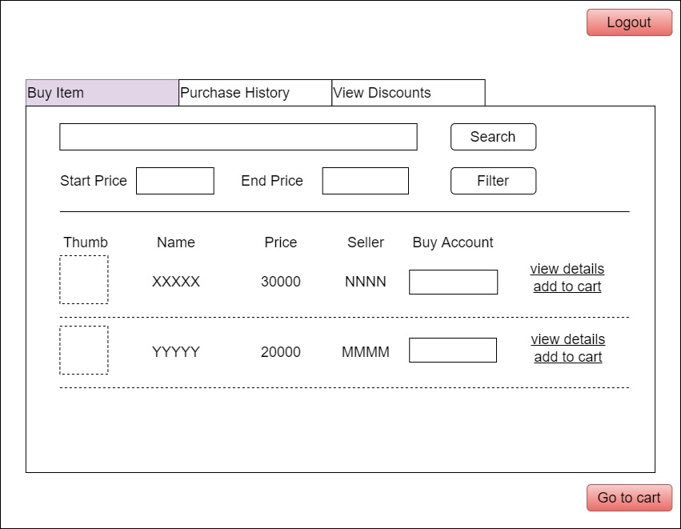

EMART003: [Purchase History] tab

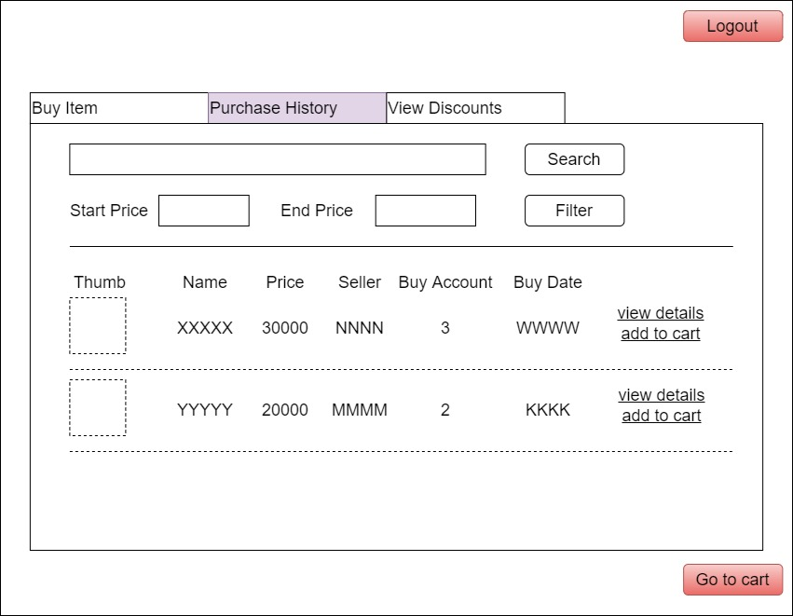s

EMART004:

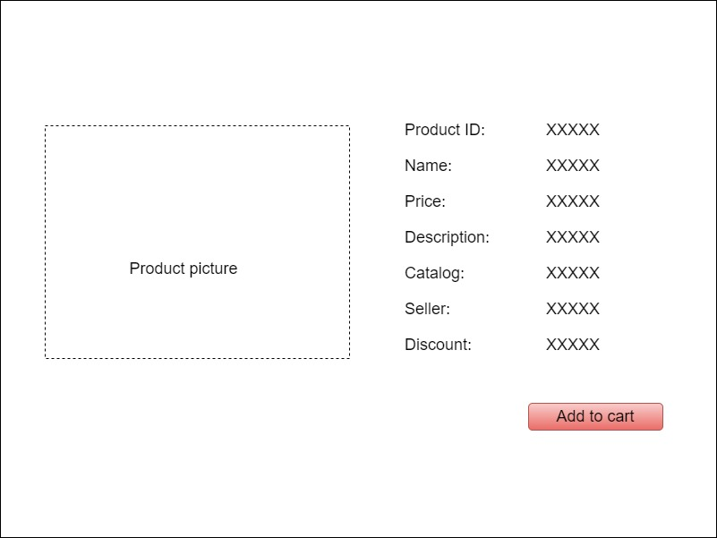

EMART005:

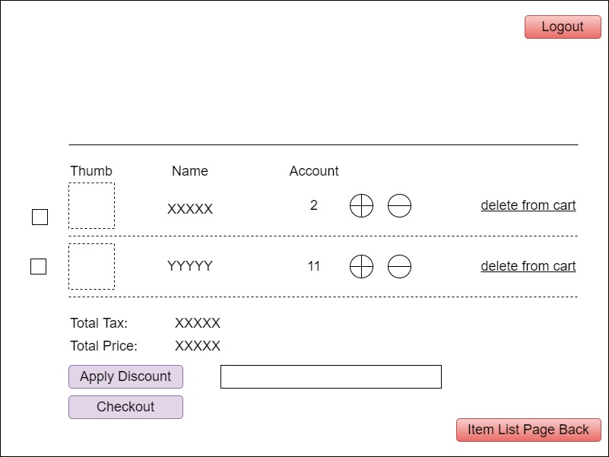

Displayed

if Apply Discount

EMART006:

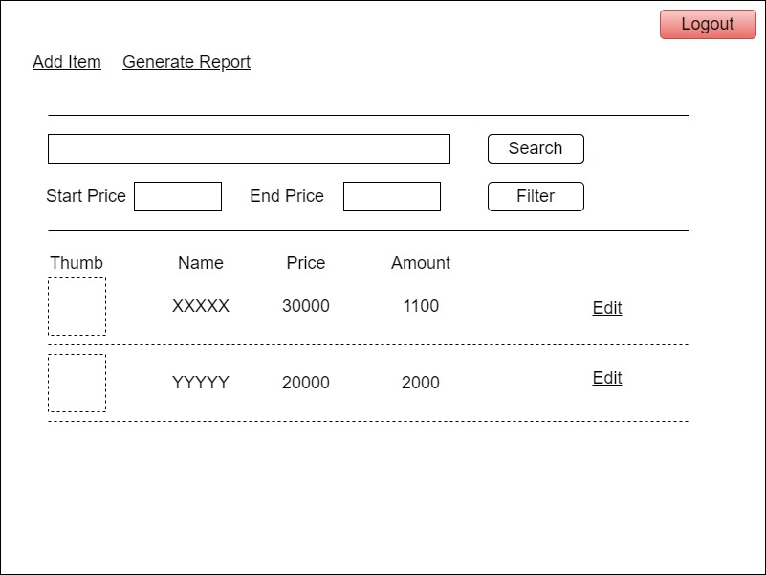

EMART007:

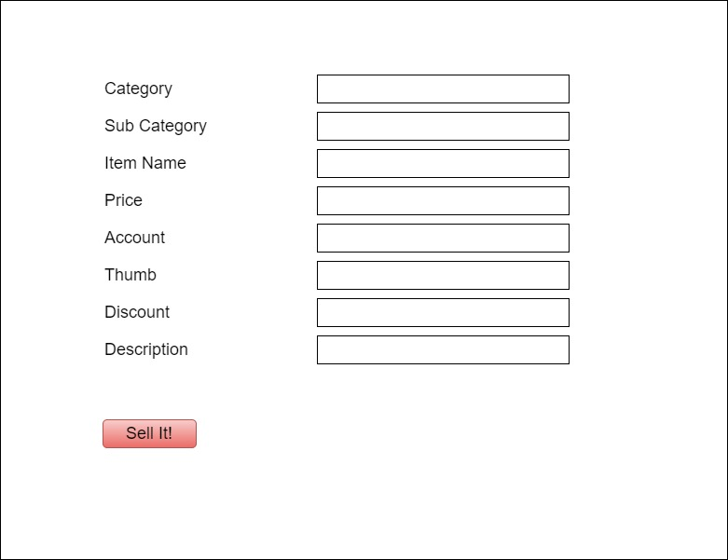

EMART008:

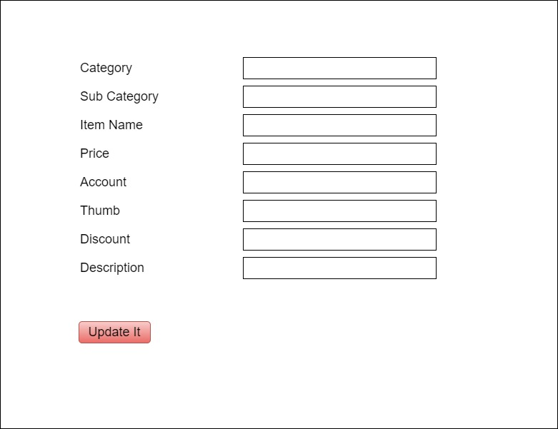

EMART009:

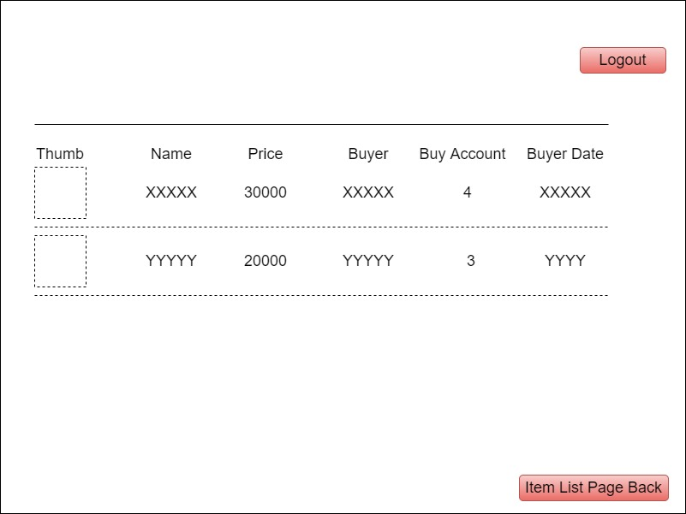

* 1. Pages ScreenFlow

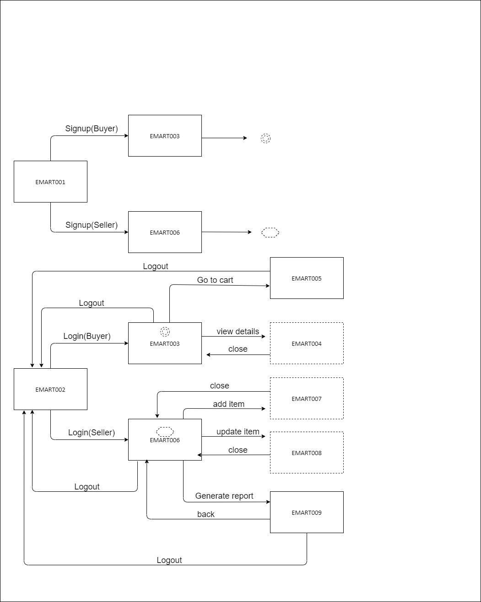

1. Data Structure 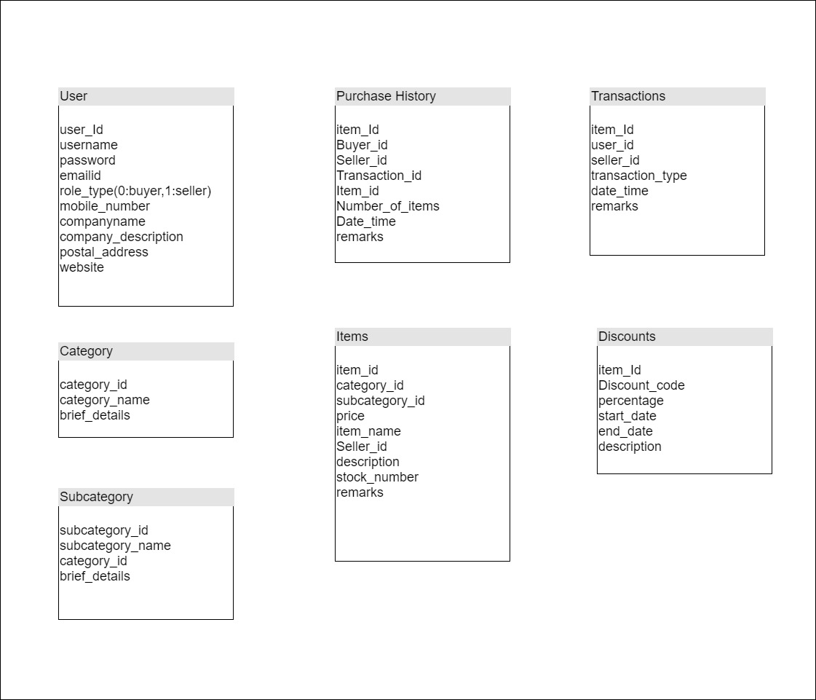
2. System Architecture

